“EDUCATION OF HUMAN POWER FOR TECHNOLOGICAL EXCELLENCE”

“LOGGING DATA SENSOR”

For the MINI PROJECT-I

In

Electrical Engineering Department

**Project Report**

By

**Bhadoriya Aryan Singh**

**Gaurav Manoj Patil**

**Aniket Rajesh Raut**

**Madhura Anil Dhobe**

**Mokshada Digambar Chaudhari**

Under the Guidance of **Prof. C.W.Jadhao**

**(2022-2023)**

**SHRI GURU GOBIND SINGHJI INSTITUTE OF ENGINEERING AND**

**TECHNOLOGY NANDED-431606 [M.S.] INDIA**

**(An Autonomous Institute of Govt. of Maharashtra)**

CERTIFICATE

This is to certify that the project entitled **“Logging Data Sensor”** in the partial fulfillment of the “Mini Project-1, 3rd year” for Shri Guru Gobind Singhji Institute of Engineering and Technology, Vishnupuri, Nanded. This bonafide work carried and completed under guidance and supervision of our guide Prof. C.W.Jadhao during academic schedule 2022-2023.

SUBMITTED BY:

Bhadoriya Aryan Singh

Gaurav Manoj Patil

Aniket Rajesh Raut

Madhura Anil Dhobe

Mokshada Digambar Chaudhari

Dr. V.G.Asutkar Prof. C.W.Jadhao

(Head Dept. of Electrical Engg.) (Project Guide)

# DECLARATION

We hereby declare that we have formed, completed and written the Report entitled “**Logging Data Sensor**”. It has not previously submitted for the basis of the Mini Project-1 for 3rd year course.

Bhadoriya Aryan Singh

(2020BEL032)

Gaurav Manoj Patil

(2020BEL019)

Aniket Rajesh Raut

(2020BEL021)

Madhura Anil Dhobe

(2020BEL005)

Mokshada Digambar Chaudhari

(2021BEL504)

Place: NANDED Date: 19/10/2022

# ABSTRACT

Power is most important requirement for all of us. We know that due to large demand of electricity and due to limit capacity of power plant at generating station, power cut off is common for all us. Due to limited amount of power generation at power station and due to shortage of nonrenewable continuous supply source it beings a biggest challenge in whole world. If you see all around us you will observe that due to discontinuity of power supply, many problems have been faced by people in their everyday use. This type of power failure create problem for data centers, hospitals and some research work. This is a biggest reason that all countries are researching for the work to supply a continuous power with good efficiency and with good regulation. In this project we can combine the renewable and non-renewable energy sources to get the continuous power supply such as mains, solar, battery, small generator. The power cut of these sources can be manually done by switches. The continuous supply to load can be given by automatic operation of relay, relay driver IC with the help of 8051 series microcontroller.

In present time’s electric supply is very essential to the human beings. Uninterrupted power supplies are needed in almost all of the areas in our life-in household applications, research institutions, hospitals etc. Due to the increased demand of power and large consumption of conventional energy sources, which are limited in nature, there is a need to shift from conventional methods of energy production to a better approach using hybrid systems to economically use the conventional and non-conventional sources. Multiple sources increase the reliability of the system and the system is more robust to power failures and faults. The project implements micro controller-based circuit with relays to facilitate for shift of power supply from the various available sources.

We express our sincere gratitude to Prof. C.W.Jadhao of Electrical Engineering dept. for his stimulating guidance, continuous encouragement and supervision throughout the course of present work.

We would like to place on record our deep sense of gratitude to Dr. V.G.Asutkar head of Electrical Engineering Department for his generous guidance, help and useful suggestions.

Lastly, we would like to thank all our friends and library staff members whose encouragement and suggestion helped us to complete our project. We are also thankful to all those persons, who have contributed directly or indirectly in the completion of this project.

Thank you!

|  |  |  |
| --- | --- | --- |
| SR. NO. | CONTENTS | PAGE NO. |
| 1 | INTRODUCTION |  |
| 2 | INTRODUCTION TO ARDUINO NANO-33 IoT |  |
| 3 |  |  |
| 4 |  |  |
| 5 |  |  |
| 6 |  |  |
| 7 |  |  |
| 8 |  |  |
| 9 |  |  |
| 10 |  |  |
| 11 |  |  |
| 12 |  |  |

|  |  |  |
| --- | --- | --- |
| SR. NO. | FIGURE NAME | PAGE NO. |
| 1 | LOGGING DATA SENSOR IN MS EXCEL THROUGH MATLAB-GUI |  |
| 2 |  |  |
| 3 |  |  |
| 4 |  |  |
| 5 |  |  |
| 6 |  |  |
| 7 |  |  |
| 8 |  |  |
| 9 |  |  |
| 10 |  |  |
| 11 |  |  |
| 12 |  |  |
| 13 |  |  |
| 14 |  |  |
| 15 |  |  |
| 16 |  |  |
| 17 |  |  |
| 18 |  |  |
| 19 |  |  |
| 20 |  |  |
| 21 |  |  |
| 22 |  |  |
| 23 |  |  |
| 24 |  |  |
| 25 |  |  |
| 26 |  |  |
| 27 |  |  |
| 28 |  |  |
| 29 |  |  |
| 30 |  |  |
| 31 |  |  |
| 32 |  |  |

1. **Introduction**
   1. **Overview**

The measurement and analysis of environmental parameters such as temperature, humidity, air quality, etc. play a crucial role in providing information about the process/system under consideration. Data is logged into a computer (using a process called data acquisition) and acquired data is analyzed either in online or offline mode. Time and frequency domain analysis of the data is then carried out to provide various information about the system, such as its mathematical model, static and dynamic characteristics, fault identification, and so on.

This project presents a MATLAB graphical user interface (GUI)-based approach for logging sensor data, i.e., to save real-time process data obtained from a temperature sensor in MS Excel. The GUI allows the user to graphically view the temperature variation at the end of sensor data acquisition. The picture below represents the GUI shown in Figure.

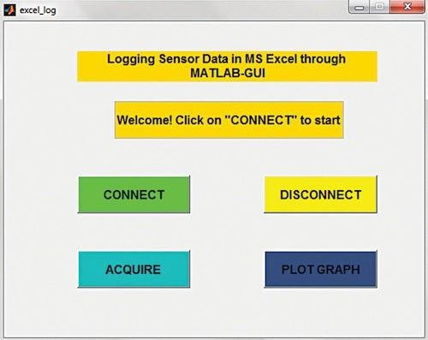

* 1. **Need and significance of the project:**

Data logging means to record events, observations, or measurements systematically. And, the device involved in data logging is known as a data logger. Data loggers come into picture whenever there’s a need to take continuous readings of an instrument. Significantly used in the field of meteorological department and scientists, data loggers are a necessary device.

Some of the typically monitored physical characteristics include:

1. **INTRODUCTION TO ARDUINO NANO 33 IOT**

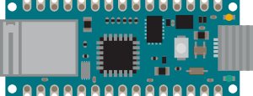

* 1. **Description**

Nano 33 IoT and Nano 33 IoT with headers is a miniature sized module containing a Cortex M0+ SAMD21 processor, a WiFi+BT module based on ESP32, a crypto chip which can securely store certificates and pre-shared keys and a 6 axis IMU. The module can either be mounted as a DIP component (when mounting pin headers), or as a SMT component, directly soldering it via the castellated pads.

* 1. **The Board**

As all Nano form factor boards, Nano 33 IoT and Nano 33 IoT with headers does not have a battery charger but can be powered through USB or headers. NOTE: Arduino Nano 33 IoT and Nano 33 IoT with headers only supports 3.3V I/Os and is NOT 5V tolerant so please make sure you are not directly connecting 5V signals to this board or it will be damaged. Also, as opposed to Arduino Nano boards that support 5V operation, the 5V pin does NOT supply voltage but is rather connected, through a jumper, to the USB power input.

* 1. **Application Examples:**
* Weather station: Using the Arduino Nano 33 IoT or Nano 33 IoT with headers together with a sensor and a OLED display, we can create a small weather station communicating temperature, humidity etc. directly to your phone.
* Air quality monitor: Bad air quality may have serious effects on your health. By assembling the board, with a sensor and monitor you can make sure that the air quality is kept in indoor-environments. By connecting the hardware assembly to an IoT application/API, you will receive real time values.
* Air drum: A quick and fun project is to create a small air drum. Connect your board and upload your sketch from the Create Web Editor and start creating beats with your audio workstation of your choice.
  1. **Board Operation:**
     1. Getting Started - IDE If you want to program your board while offline you need to install the Arduino Desktop IDE. To connect the Arduino 33 IoT to your computer, you will need a Micro-B USB cable. This also provides power to the board, as indicated by the LED.
     2. Getting Started - Arduino Web Editor All Arduino boards, including this one, work out-of-the-box on the Arduino Web Editor, by just installing a simple plugin. The Arduino Web Editor is hosted online, therefore it will always be up-to-date with the latest features and support for all boards. Follow to start coding on the browser and upload your sketches onto your board.
     3. Getting Started - Arduino IoT Cloud All Arduino IoT enabled products are supported on Arduino IoT Cloud which allows you to Log, graph and analyze sensor data, trigger events, and automate your home or business.
     4. Sample Sketches Sample sketches for the Arduino 33 IoT can be found either in the “Examples” menu in the Arduino IDE or in the “Documentation” section of the Arduino Pro website
     5. Online Resources Now that you have gone through the basics of what you can do with the board you can explore the endless possibilities it provides by checking exciting projects on ProjectHub, the Arduino Library Reference and the online store where you will be able to complement your board with sensors, actuators and more
     6. Board Recovery All Arduino boards have a built-in bootloader which allows flashing the board via USB. In case a sketch locks up the processor and the board are not reachable anymore via USB it is possible to enter bootloader mode by double-tapping the reset button right after power up.
  2. **Connectors Pinouts:**

|  |  |  |  |
| --- | --- | --- | --- |
| Pin | Function | Time | Description |
| 1 | VUSB | Power | Power Supply Input. If board is powered via  VUSB from header this is an Output (1) |
| 2 | D- | Differential | USB differential data - |
| 3 | D+ | Differential | USB differential data + |
| 4 | ID | Analog | Selects Host/Device functionality |
| 5 | GND | Power | Power Ground |

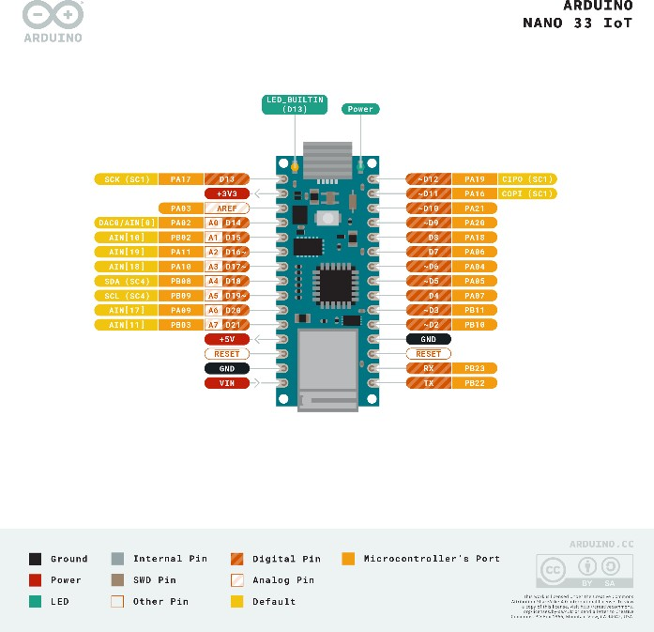

* + 1. **USB**
    2. **Headers**

The board exposes two 15 pin connectors which can either be assembled with pin headers or soldered through castellated vias.

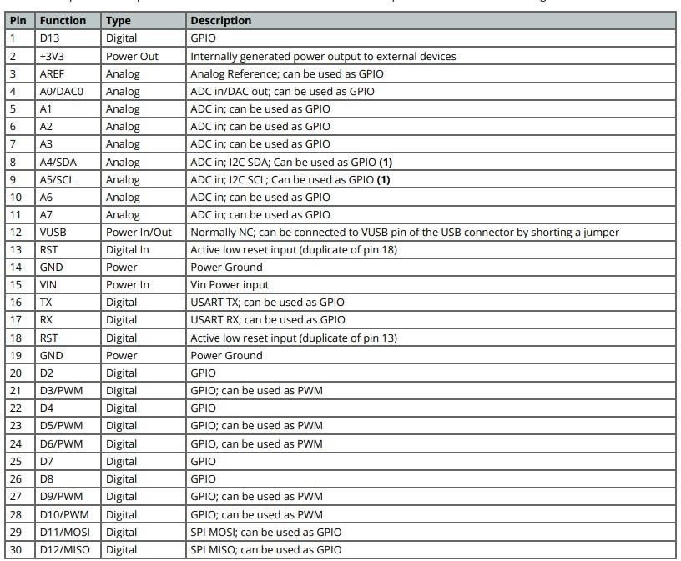

* + 1. **Debug**

On the bottom side of the board, under the communication module, debug signals are arranged as 3x2 test pads with 100 mil pitch. Pin 1 is depicted in Figure 3 – Connector Positions

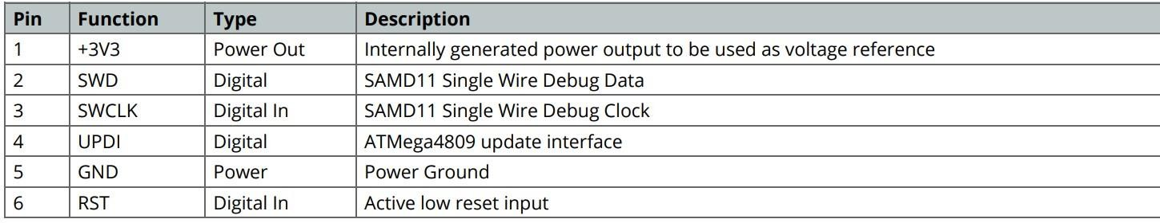

Figure 1: Block Diagram

* 1. **Connectors Pinouts:**
     1. **Board Topology**

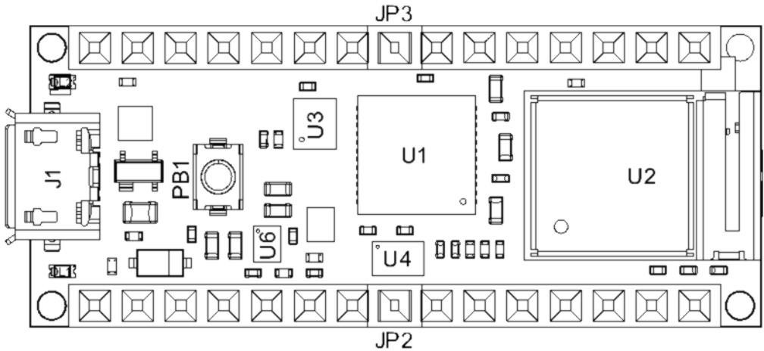

Board topology top

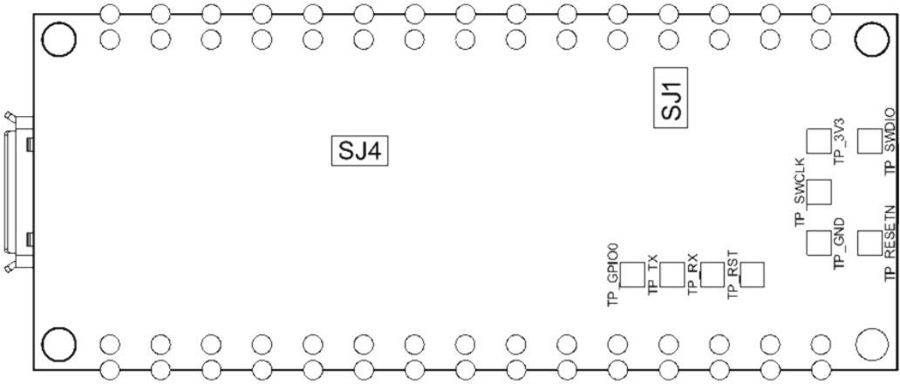

Board topology bottom

* + 1. **Processor**

The Main Processor is a Cortex M0+ running at up to 48MHz. Most of its pins are connected to the external headers, however some are reserved for internal communication with the wireless module and the on-board internal I2C peripherals (IMU and Crypto). NOTE: As opposed to other Arduino Nano boards, pins A4 and A5 have an internal pull up and default to be used as an I2C Bus so usage as analog inputs is not recommended. Communication with NINA W102 happens through a serial port and a SPI bus through the following pins.

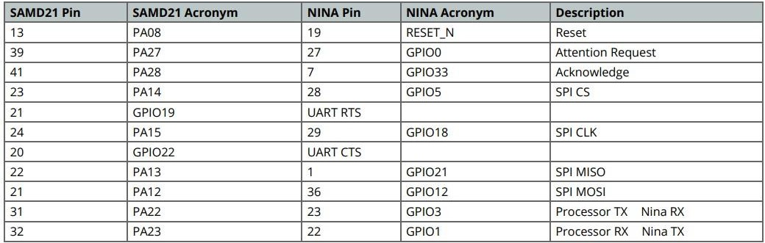

* + 1. **WiFi/BT Communication Module**

Nina W102 is based on ESP32 and is delivered with a pre-certified software stack from Arduino. Source code for the firmware is available [9]. NOTE: Reprogramming the wireless module’s firmware with a custom one will invalidate compliance with radio standards as certified by Arduino, hence this is not recommended unless the application is used in private laboratories far from other electronic equipment and people. Usage of custom firmware on radio modules is the sole responsibility of the user. Some of the module’s pins are connected to the external headers and can be directly driven by ESP32 provided SAMD21’s corresponding pins are aptly tri-stated. Below is a list of such signals:

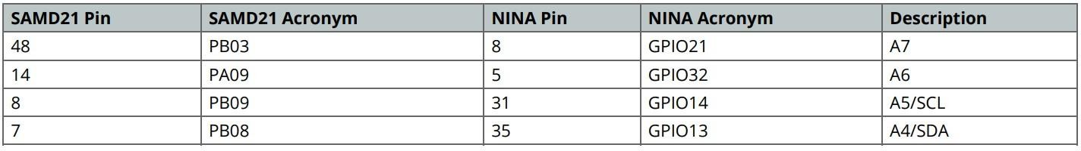

* + 1. **Crypto**

The crypto chip in Arduino IoT boards is what makes the difference with other less secure boards as it provides a secure way to store secrets (such as certificates) and accelerates secure protocols while never exposing secrets in plain text. Source code for the Arduino Library that supports the Crypto is available.

* + 1. **IMU**

The board has an embedded 6 axis IMU which can be used to measure board orientation (by checking the gravity acceleration vector orientation) or to measure shocks, vibration, acceleration, and rotation speed. Source code for the Arduino Library that supports the IMU is available.

* + 1. **Power Tree**

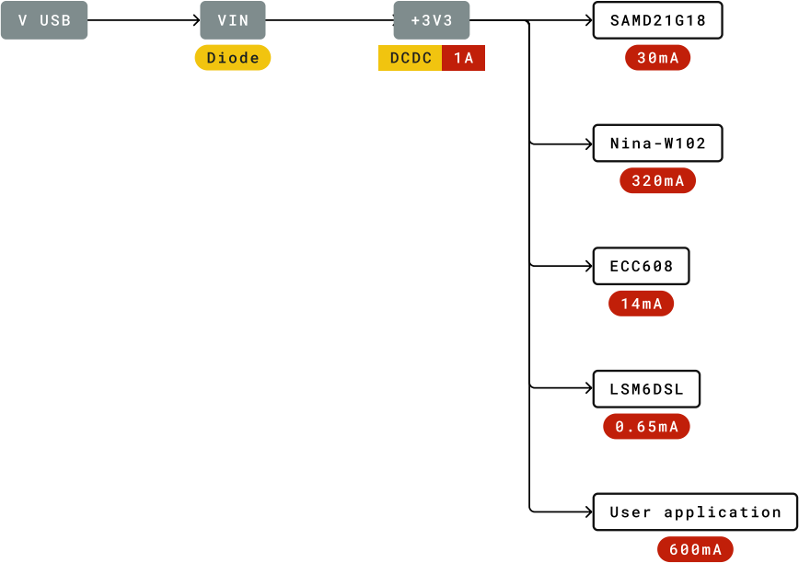

* 1. **Connectors Pinouts:**
     1. **Board Outline and Mounting Holes:**

The board measures are mixed between metric and imperial. Imperial measures are used to maintain a 100-mil pitch grid between pin rows to allow them to fit a breadboard whereas board length is Metric.

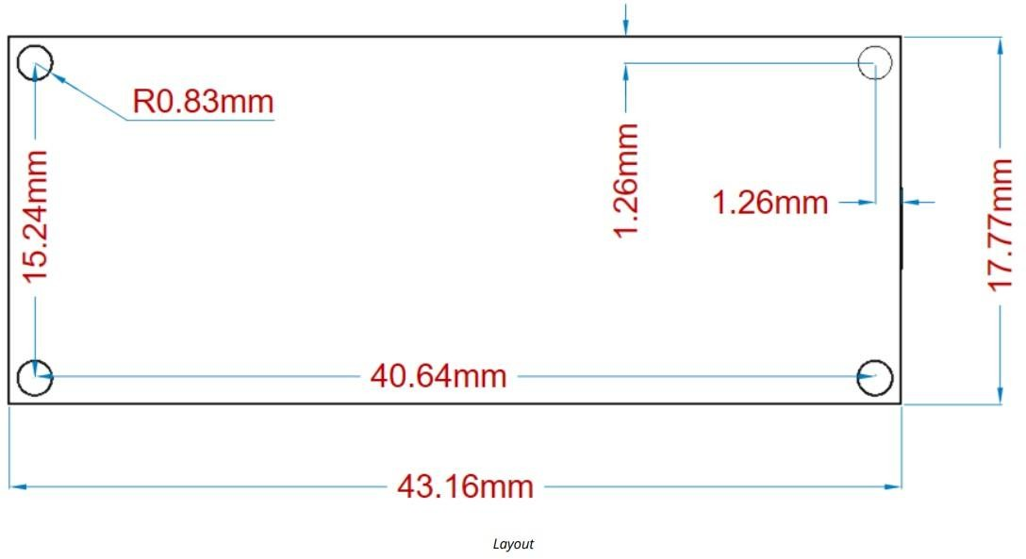

* + 1. **Connector Positions**

The view below is from top however it shows Debug connector pads which are on the bottom side. Highlighted pins are pin 1 for each connector.

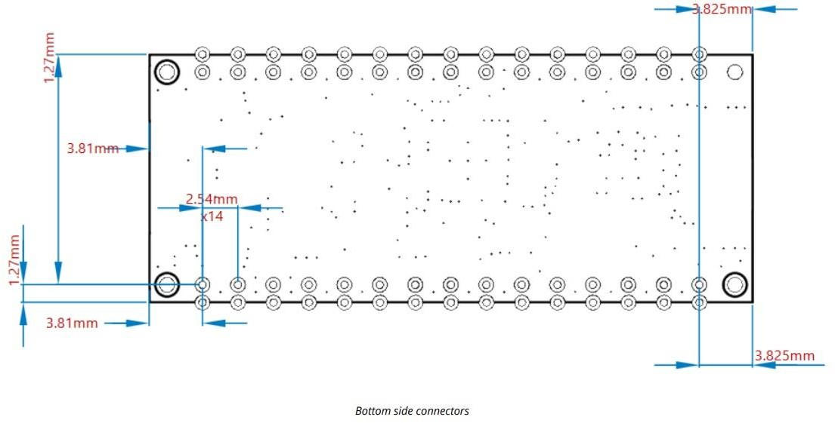

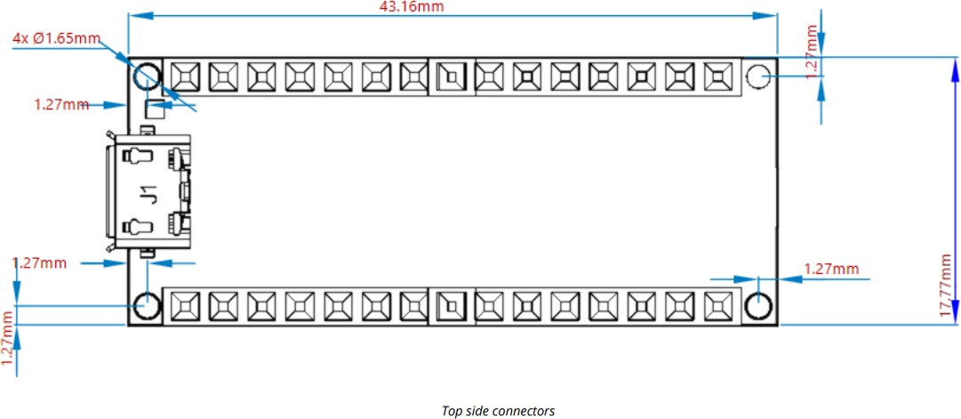

## SENSORS

### Introduction

Sensors capture and translate their physical attributes into observable electrical impulses from chosen surroundings. Temperature, mass, speed, pressure, or heat bodies such as people are included as these attributes. A microprocessor processes the electrical impulses to provide outputs that correspond to a set of measures. The system sends the output to the recipients in the designated devices. A system can use many sensors with varied capacities, depending on functional complexity and increasing functional requirements. Sensors increase the capability of the world around us to observe and report. They are made to work to make human lives considerably more accessible and better in nearly all fields. Setting up moods, switching on water heaters, guaranteeing safety, tracking equipment, and more are some of them. Sensors allow better visibility incorporate processes and workflows, analyse patterns of employees' work, and detect environmental conditions in facilities on a larger scale. These can monitor, regulate, and increase operational efficiency in business management.

Electrical sensors transform a stimulus into an electrical signal, then processed by the computer into meaningful end-user information. Sensors for medicine are one of the most complex technologies to design and reliably integrate with Smartphones and the Internet of Things (IoT) with the necessary capabilities. Biological sensors employ biological molecules to detect objective chemicals as receptors. These key technological elements monitor the heat that an object or system releases. These allow us to feel a temperature shift bodily. Prevention is a crucial function of [temperature sensors.](https://www.sciencedirect.com/topics/chemistry/thermal-sensor) When a predefined high point occurs, temperature sensors detect time for preventive action.

Today, the world has advanced so far that many key processes would not be restored without sensor data. These are used in our homes, at our shopping centres, and our hospitals. They are included in Smartphone's and are part of the IoT. Cost reduction and a dramatic improvement in guest experience are achieved with sensors built for smart hotels. In automating temperature controls and light settings, the thermostats and occupancy sensors offer smart energy management, making sensible energy use. Sensor-based technologies change the way people connect and work in today's workplace. This change involves intelligent sensors, which provide enhanced productivity and performance.

Since sensors are far smaller than hair in textiles, the wearer of the garment is rarely noticeable. A new generation of tissue-integrated sensors can monitor innovatively biological happenings. Biosensors are taking vital monitoring of daily life activities of the health. These biosensors are not isolated from the body but function entirely inside the body without metal and electronic components. This technology provides additional security and relief in everyday life, particularly for chronically sick people. It can be mounted on the upper arm and enables a discrete blood glucose measurement. This study shows various sensors and their capacities for day-to-day healthcare. The major strength of this paper is to identify and discuss various [applications of](https://www.sciencedirect.com/topics/chemistry/application-of-sensors) [sensors](https://www.sciencedirect.com/topics/chemistry/application-of-sensors) for daily life.

### What are sensors?

A sensor is a device, module, machine, or subsystem that detects events or changes in its environment and relays the information to other electronics, most commonly a computer processor. A sensor converts physical phenomena into a measurable digital signal, which can then be displayed, read, or processed further. The figure illustrates the working of a sensor. Various specialists and researchers classify sensors in a variety of ways. In the first classification, the sensors are divided into Active and Passive categories. To work, active sensors need an external excitation signal or a power signal.

On the other hand, passive sensors do not require any external power and produce an output response. GPS and radar are examples of active sensors that require an external power source to operate. Active remote sensing techniques such as RADAR and LiDAR measure the time delay between emission and return to determine an object's location, speed, and direction. Passive sensors, also known as self-generated sensors, produce their own electric signal and do not require external power. [Thermal sensors](https://www.sciencedirect.com/topics/chemistry/thermal-sensor), electric field sensing, and metal detection are examples of these. The sensor's detecting method is used in the other categorisation method. Detection methods include electric, biological, chemical, radioactive, and other methods. Another classification is based on conversion phenomena, such as input and output. [Thermoelectric,](https://www.sciencedirect.com/topics/chemistry/thermoelectricity) [Photoelectric](https://www.sciencedirect.com/topics/chemistry/photoelectricity), Electrochemical, Electromagnetic, Thermo-optic, and other common conversion processes are only a few examples. The illustration view on the working of sensor is shown in figure.

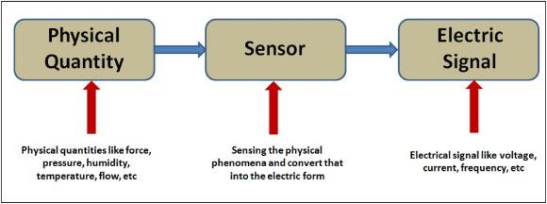

### Sensors used in Hardware

* + 1. **Fermion: BME680 Environmental Sensor (Breakout)**

**Introduction**- BME680 is a 4-in-1 multi-functional MEMS environmental sensor which integrates VOC (Volatile Organic Compounds) sensor, temperature sensor, humidity sensor and barometer. It is designed for air quality monitor, and due to the MEMS technology, BME680 has a small size and low power consumption. It can be widely used in environmental monitoring, home automation and control, Internet of Things (IoT) wearable device, GPS enhancement, etc.

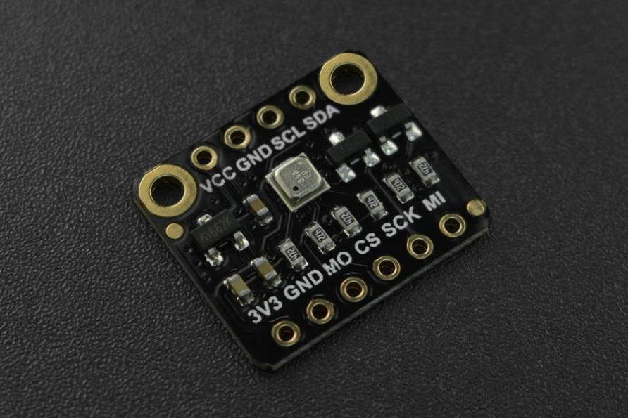

This BME680 Sensor adopts more simplified breakout design and leads out pitch 2.54 pin/female and SPI connectors. And it has onboard voltage regulator IC and I2C level translator circuit, which makes this sensor more convenient to be integrated into various applications.

With the development of industrialization, air pollution is getting worse and worse. Toxic chemical odors are even common with new furniture. These invisible killers are destroying your health day by day. You do need to concern about your health as soon as possible and this DFRobot Breakout BME680 environmental sensor can help you make an air quality monitor to take good care of your health!

# FEATURES

* + - * + MEMS sensor, small size, low power consumption, high reliability
        + Wide voltage input, compatible with 3.3V and 5V controller
        + Highly integrated environmental sensor: temperature, humidity, barometer and VOC, four- in-one environmental parameter monitoring
        + I2C connector, plug and play
        + Small size and easy to install

# SPECIFICATION

* + - * + Input Voltage: 3.3V~5.5V
        + Operating Current: 5mA (25mA in VOC Measurement)
        + Communication Interface: I2C (Support 3.3V/5V) or SPI (other non-I2C ports only support 3.3V)
        + Default I2C Address: 0x76
        + Temperature Measurement Range: -40℃~+85℃
        + Temperature Measurement Precision: ±1.0℃ (0~65℃)
        + Humidity Measurement Range: 0-100%r.H.
        + Humidity Measurement Precision: ±3%r.H. (20-80% r.H.,25℃)
        + Atmospheric Pressure Measurement Range: 300-1100hPa
        + Atmospheric Pressure Measurement Precision: ±0.6hPa(300-1100hPa,0~65℃)
        + IAQ (Indoor Air Quality) Range: 0~500 (the larger, the worse)
        + Dimension: 18×15.6(mm) /0.71x0.61(inches)

### Sensors used in Hardware

A relay is an electrically operated switch. Current flowing through the coil of the relay creates a magnetic field which attracts a lever and changes the switch contacts.

There are different types of relays available and they can be categorized in various ways, here we have used SPDT switch (single pole Double throw) with 12v Supply.

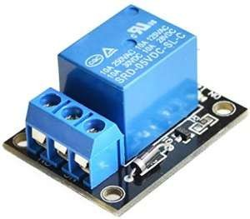

### Relay Driver IC

Figure 3: Relay

In this multi power supply control system, the relay driver IC is used for driving the load relays. This relay receives the signal from microcontroller for shifting the load on another supply source. It is powered up with 5V dc and interfaced with microcontroller.

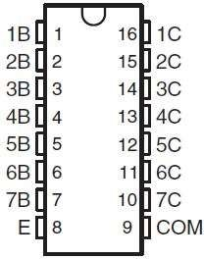

Figure 4: Relay Driver IC

### LCD

In this multi power supply control system, the LCD display is used for displaying the source of supply on which the whole system or load has shifted. Most common LCDs connected to the microcontrollers are 16x2 and 20x2 displays

LCD (Liquid Crystal Display) is an electronic display which is commonly used nowadays in applications such as calculators, laptops, tablets, mobile phones etc. 16×2 character LCD

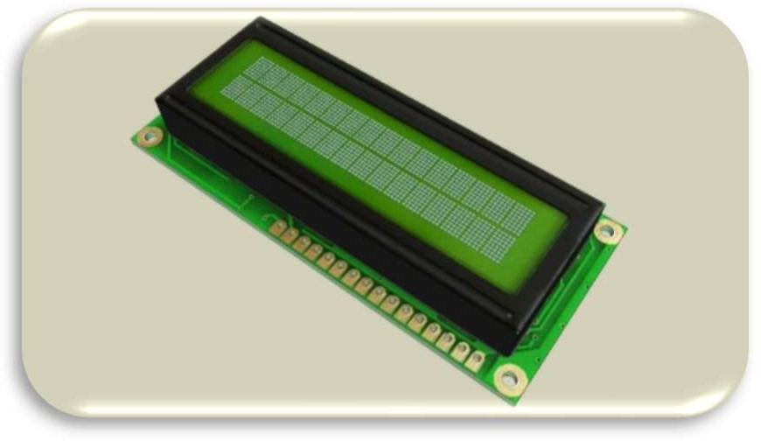module is a very basic module which is commonly used by electronic hobbyists and is used in many electronic devices and project. It can display 2 lines of 16 characters and each character is displayed using 5×7 or 5×10 pixel matrix. Here it is interfaced with microcontroller and powered up with 5V dc.

Figure 5: LCD

|  |  |  |
| --- | --- | --- |
| **Pin Function Name**  **No** | | |
| **1** | Ground (0V) | Ground |
| **2** | Supply voltage; 5V (4.7V – 5.3V) | Vcc |
| **3** | Contrast adjustment; through a variable resistor | VEE |
| **4** | Selects command register when low; and data register when high | Register Select |
| **5** | Low to write to the register; High to read from the register | Read/write |
| **6** | Sends data to data pins when a high to low pulse is given | Enable |
| **7** | 8-bit data pins | DB0 |
| **8** | DB1 |
| **9** | DB2 |
| **10** | DB3 |
| **11** | DB4 |
| **12** | DB5 |
| **13** | DB6 |
| **14** | DB7 |
| **15** | Backlight VCC (5V) | Led+ |
| **16** | Backlight Ground (0V) | Led- |

### Filter Capacitor

A Filter Capacitor is a capacitor which filters out a certain frequency or range of frequencies from a circuit. The capacitance value is needed to minimize the voltage ripple. An electrolyte capacitor of about 470µF to 1000 µF to filter the output DC from the bridge rectifier

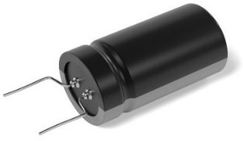

Figure 6: Filter Capacitor

### Crystals

A crystal oscillator is an electronic oscillator circuit that uses the mechanical resonance of a vibrating crystal of piezoelectric material to create an electrical signal with a constant frequency. Oscillators are used to provide clock to the microcontroller. Crystal Oscillators are preferred because they are accurate, can be used for high frequency generation, low Cost, small in Size and consume low power.

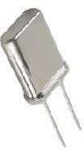

Figure 7: Crystals

### Push Button

Four push buttons are used for four sources, when a particular switch is pressed, load will receive the power from that respective source

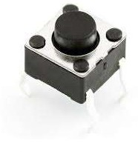

Figure 8: Push Button

### Diode

There are many types of semiconductor diodes namely Selenium, Germanium and Silicon types. Selenium type is commonly used in the early days in ac power suppliers but in recent years it has been replaced by silicon type as it sometimes emit toxic fumes when it burnt out.

The characteristic is that it allows current to flow in one direction as shown in the symbol below. It has a cathode and an anode which determine the flow of the current. Current can only flow from anode to cathode.

Silicon V-I characteristics are shown in the figure below. The junction barrier for silicon is about 0.7V and for Germanium is about 0.3V. It is also called forward voltage drop. Most of the diode used today is of silicon type as they are robust and reliable from DC to RF small signal applications.

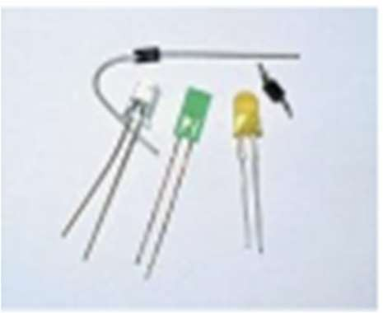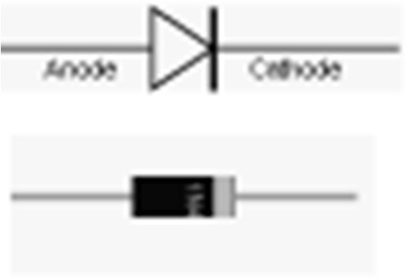

Figure 9: Diode

### Transformer

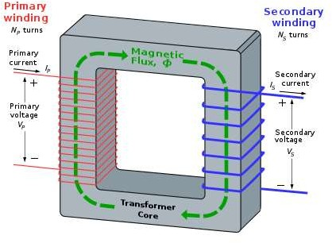The transformer is based on two principles: firstly, that an electric current can produce a magnetic field (electromagnetism) and secondly that a changing magnetic field within a coil of wire induces a voltage across the ends of the coil (electromagnetic induction). Changing the current in the primary coil changes the magnetic flux that is developed. The changing magnetic flux induces a voltage in the secondary coil.

Figure 10: Transformer

### Zener Diode

A Zener diode is a special type of diode designed to reliably allow current to flow "backwards" when a certain set reverse voltage, known as the *Zener voltage*, is reached.

Zener diodes are widely used in electronic equipment of all kinds and are one of the basic building blocks of electronic circuits. They are used to generate low-power stabilized supply

rails from a higher voltage and to provide reference voltages for circuits, especially stabilized power supplies. They are also used to protect circuits from overvoltage, especially electrostatic discharge (ESD).

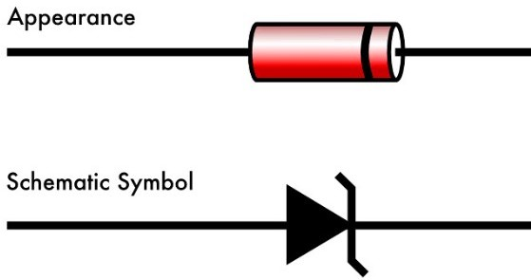

Figure 11: Zener diode

### Voltage Regulator

We use LM7805 to ensure a steady constant voltage supply through all operational conditions. It regulates voltage during power fluctuations and variations in loads also It can regulate AC as well as DC voltages.

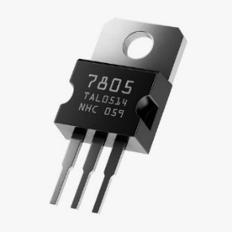

Figure 12: Voltage Regulator

### Resistor

A resistor is a passive two-terminal electrical component that implements electrical resistance as a circuit element. In electronic circuits, resistors are used to reduce current flow, adjust signal levels, to divide voltages, bias active elements, and terminate transmission lines, among other uses. High-power resistors that can dissipate many watts of electrical power as heat, may be used as part of motor controls, in power distribution systems, or as test loads for generators. Fixed resistors have resistances that only change slightly with temperature, time or operating voltage. Variable resistors can be used to adjust circuit elements (such as a volume control or a lamp dimmer), or as sensing devices for heat, light, humidity, force, or chemical activity.

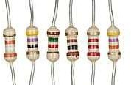

### LED

Figure 13: Resistor

LEDs are semiconductor devices are made out of silicon. When current passes through the LED, it emits photons as a byproduct. Normal light bulbs produce light by heating a metal filament until its white hot.

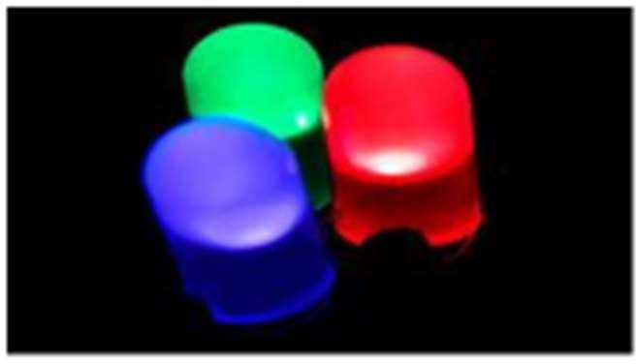LEDs present many advantages over traditional light sources including lower energy consumption, longer lifetime, improved robustness, smaller size and faster switching. They do dozens of different jobs and are found in all kinds of devices. Among other things, they form numbers on digital clocks, transmit information from remote controls, light up watches and tell you when your appliances are turned on. Collected together, they can form images on a jumbo television screen or illuminate a traffic light

Figure 14: LED

### Solar Panel

Solar energy is derived from the sun’s radiation. The sun is a powerful energy source. The energy that it provides to earth for one hour could meet the global energy needs for one entire year. We are able to harness only 0.001 percent of that energy. There is a reason why solar energy has become a trending topic when talking about renewable energies. While it has been popularly criticized for being expensive or not very efficient, solar energy has 8 now proved to be very beneficial not only for the environment but also financially speaking. Additionally, due to the higher demand the technology has been improved considerably, turning into a very efficient source of clean energy.

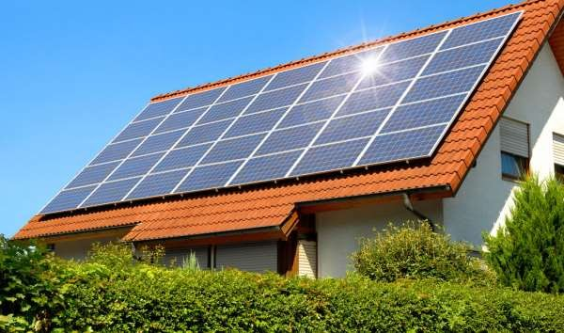

Figure 15: Solar Power

### Generator or wind Power

Wind energy offers many advantages, which explains why it’s one of the fastest growing energy sources in the world. Wind has a powerful mechanical energy able to drive large shafts of electricity generators providing clean energy.



Figure 16: Wind Power

### Main or AC Power

As our load requires 5 V dc supply so, in this source we have stepped down the voltage level from 230 V ac to 5 v DC using the voltage regulation circuit

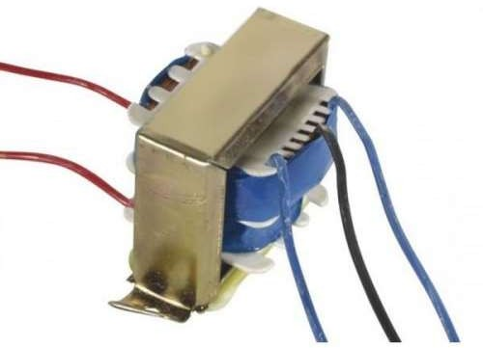

### Battery Power

Figure 17: AC Power

It is the last source according to the sequence given by us, because battery power is stored from the AC source itself. Here we have used 4v Battery as last supply to load.

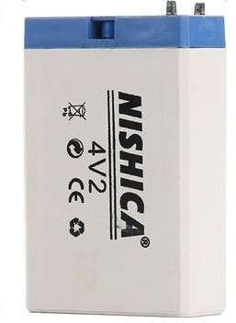

Figure 18: battery Power

## Circuit Diagram:

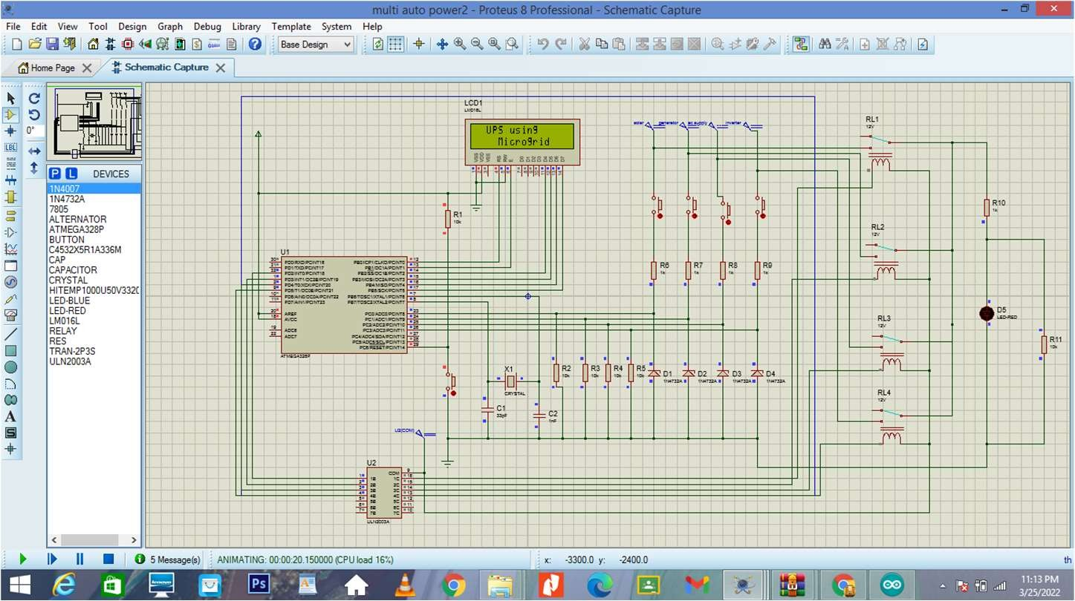

Figure 19: Circuit Diagram

## Basic Design Methodology

For the simulation purpose we have used two software’s Proteus & Arduino. Proteus is used to create schematic and electronic prints for manufacturing printed circuit boards. Arduino software is used to write programs and convert the source code to hex file.

### Simulation (Interfacing ATMEGA328P with LCD)

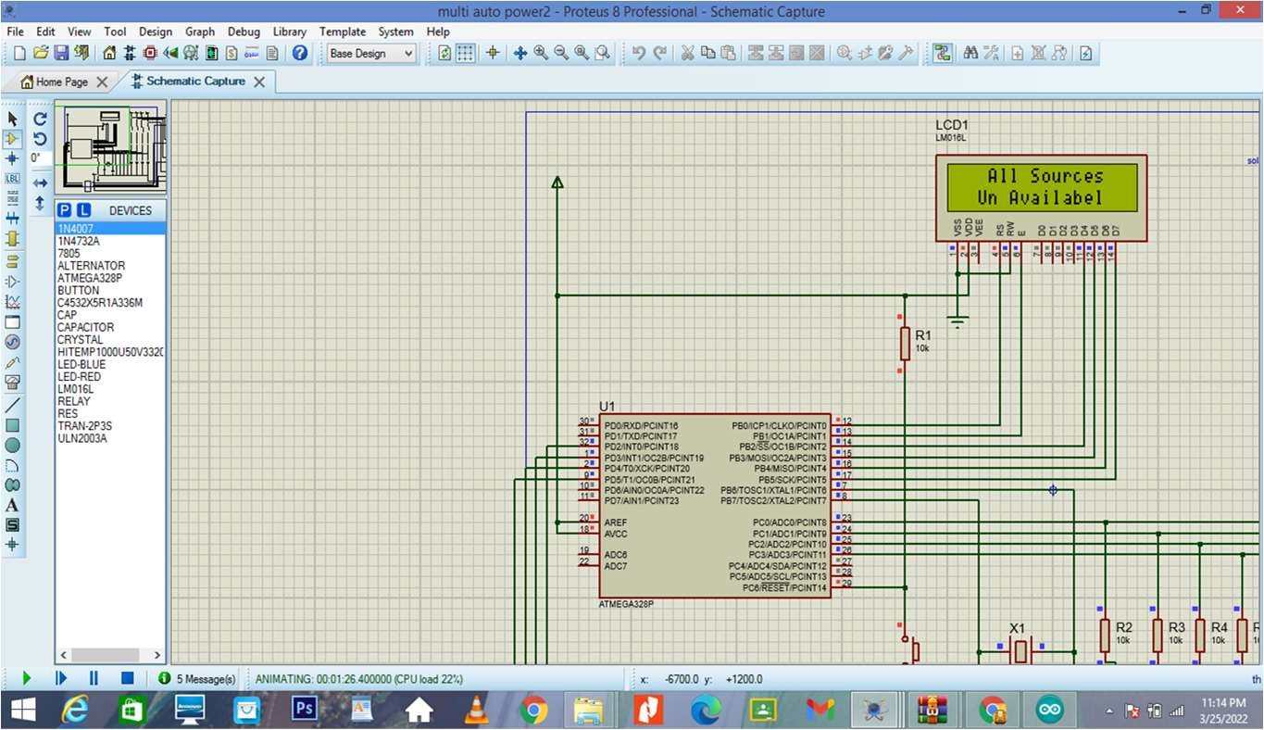

Figure 20: Simulation (Interfacing ATMEGA328P with LCD)

From the above figure it is clear that we have interfaced microcontroller with LCD successfully, also when no switch is pressed it shows the “All sources Un Available”

### Simulation (Voltage Regulation Circuit :)

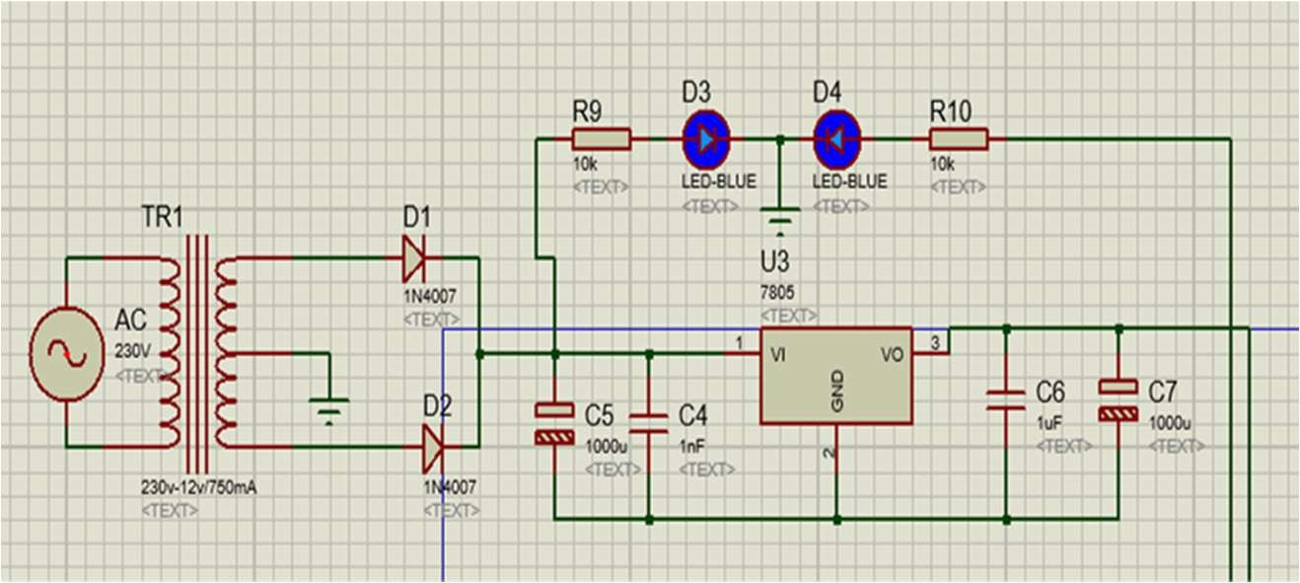

Figure 21: Simulation (Voltage Regulation Circuit)

Here transformer is used to step down the voltage from 230v to 12v. It is then converted to dc supply with the help of rectifier. And then regulated to 5v to provide power supply to LCD.

### Protection circuit:

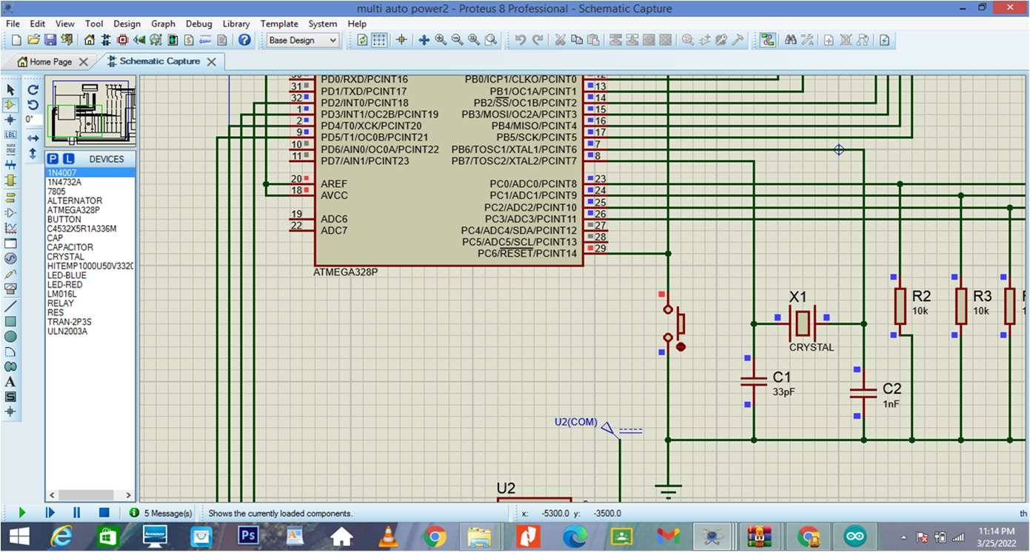

Figure 22: Simulation (Protection Circuit)

It consists of two circuits, i.e., oscillator circuit and reset circuit. Oscillator circuit consists of crystal with 16MHz frequency, and two bypass capacitors to stabilize frequency. In reset circuit, a pull up resistor and switch button are connected across reset pin, to reset the microcontroller whenever required.

## Final Project simulation

### First, initial state (when all sources are off)

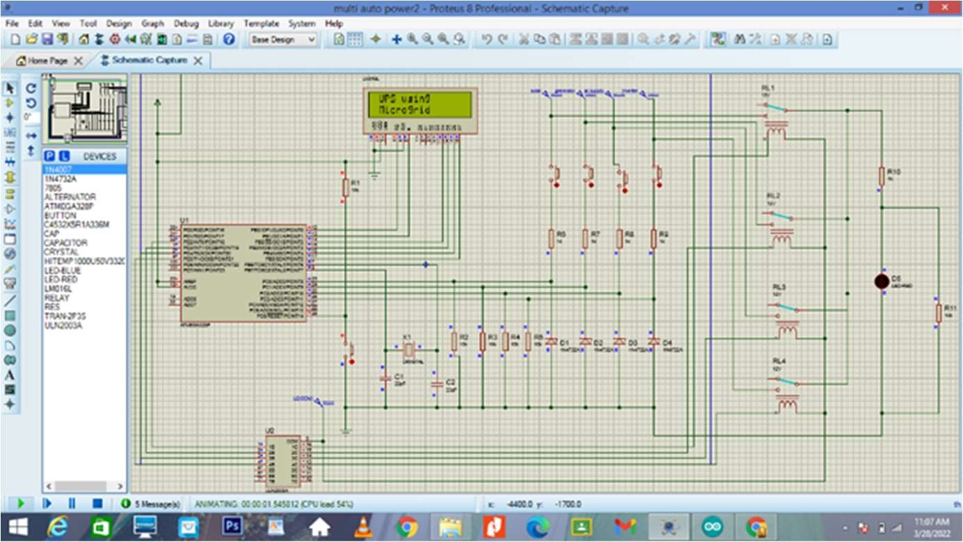

Figure 23.1: Initial State of Circuit

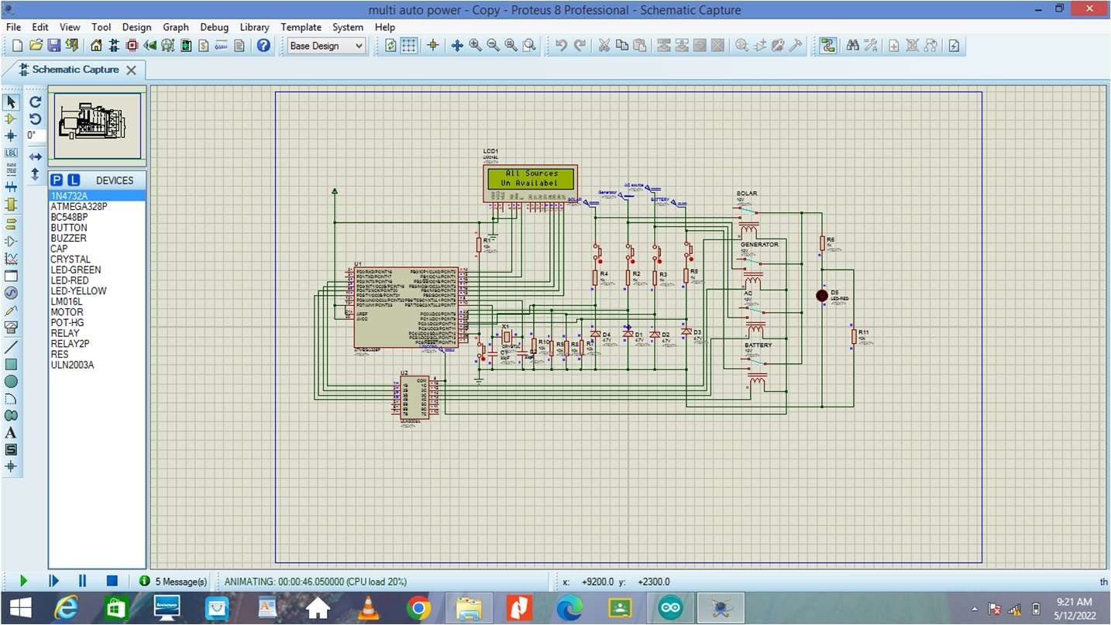

Figure 23.2: Initial State of Circuit

It is clear that when all switches are OFF there’s no power being supplied to the load

So firstly, it will display on Lcd screen “**UPS using microgrid”** after that it will change to **“All sources are unavailable”.**

### Second, when all sources are active:

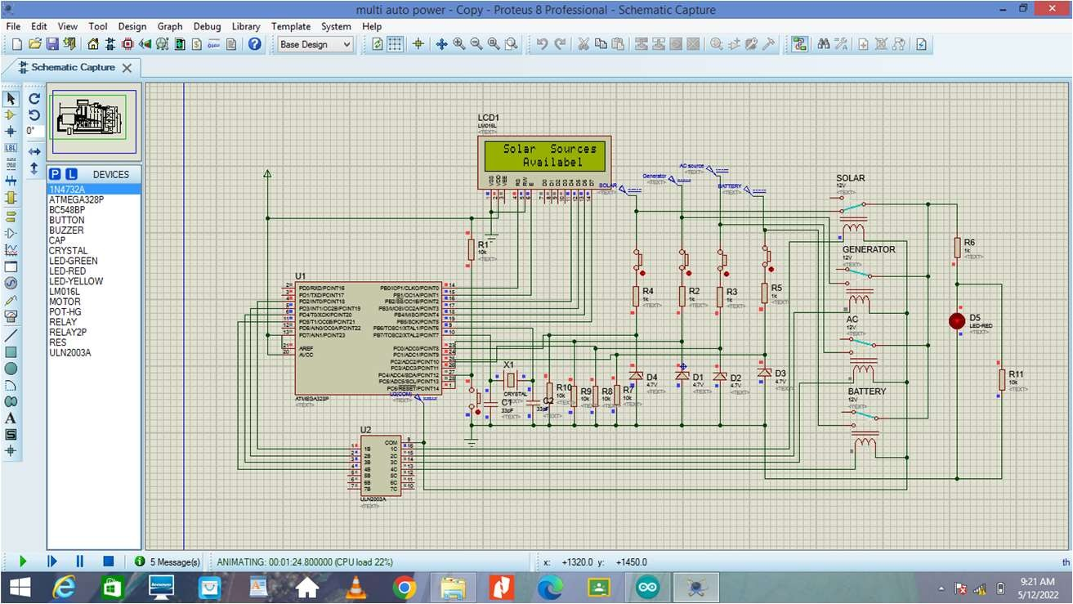

Figure 24: Simulation when solar supply is active

It is obvious that when all when all switches are pressed the respective relay with the solar source will turn on and active source is the solar power supply thus the load will receive the power from the solar power supply automatically and the screen will represent **“Solar source is available.”**

### Third, when the solar supply fails:

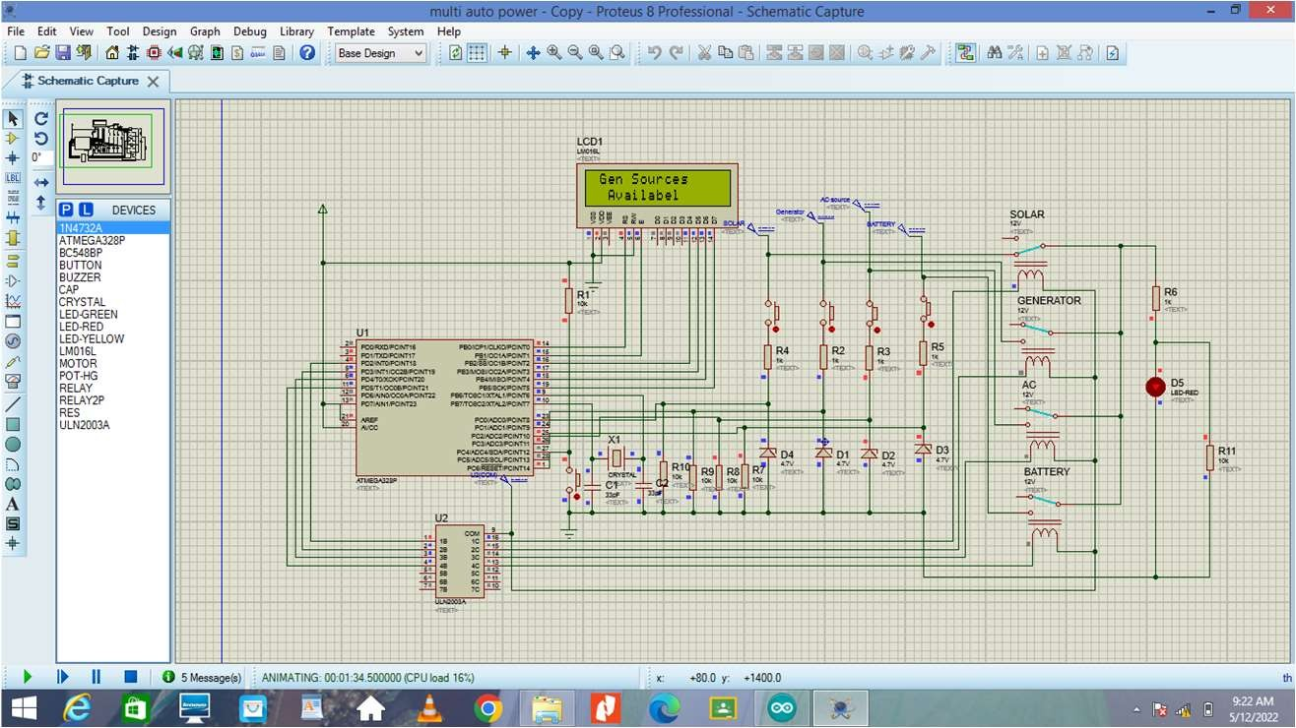

Figure 25: Simulation when generator supply is available

As solar supply fails this represents a fault being happening within the solar power supply. So,the circuit shifts to the generator supply automatically and the relay respective to generator power supply will turn on automatically also the screen status will change to **“Generator source is available”**

### Third, when the Generator supply fails:

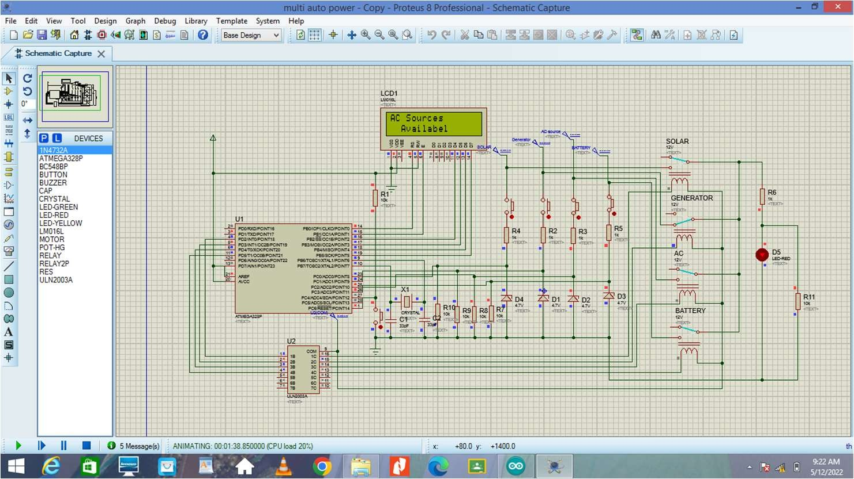

Figure 26: Simulation when ac source is available

As generator supply fails this represents a fault being happening within the solar power supply. So, the circuit shifts to the main power supply automatically and the relay respective to main power supply will turn on automatically also the screen status will change to **“AC source is available”**

### Third, when the Main supply fails:

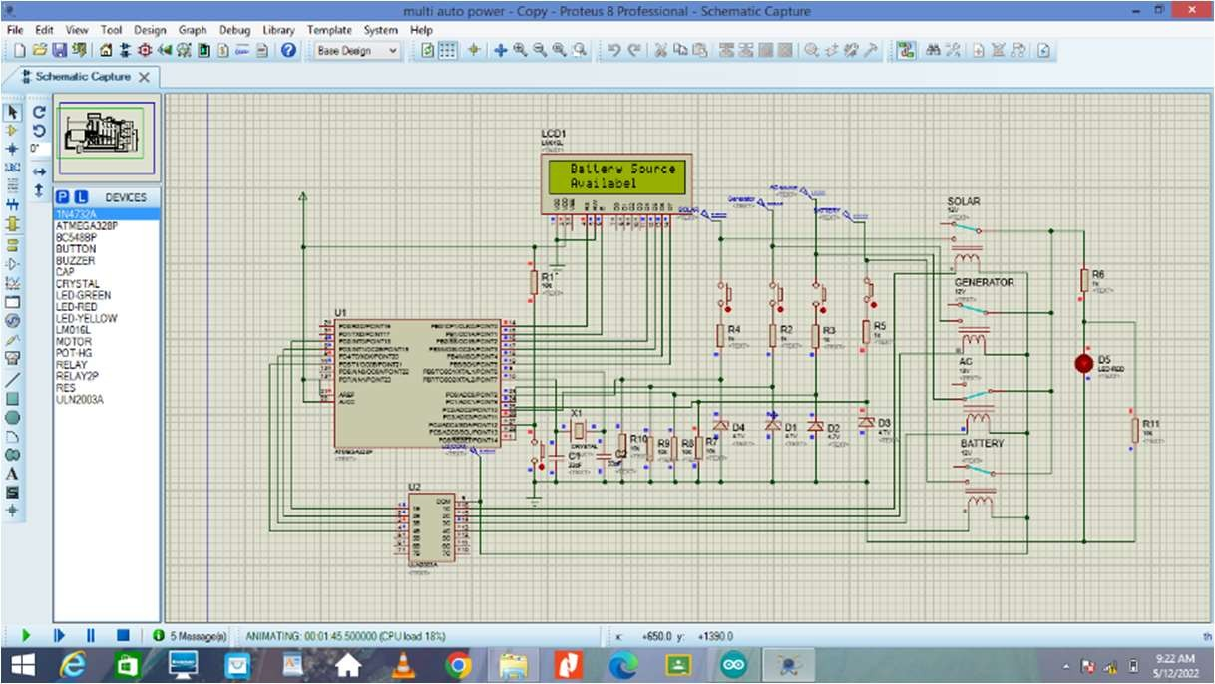

Figure 27: Simulation when battery supply is available

As generator supply fails this represents a fault being happening within the main power supply. So, the circuit shifts to the Inverter (Battery) power supply automatically and the relay respective to main power supply will turn on automatically also the screen status will change to **“Battery source is available”**

## Hardware Implementation

### First, initial state (when all sources are off)

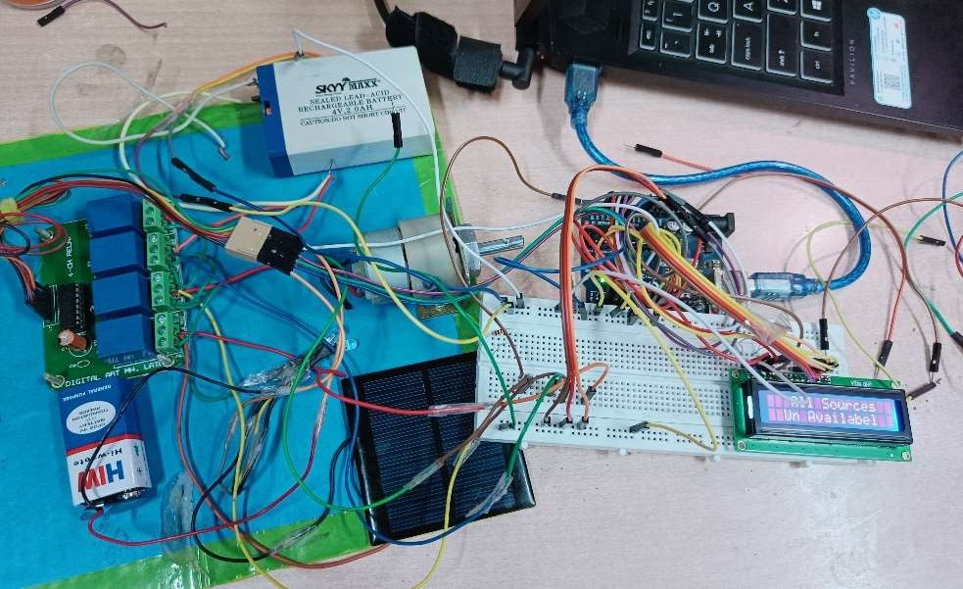

Figure 28: Hardware – All sources Unavailable

### Second, when solar source is active:

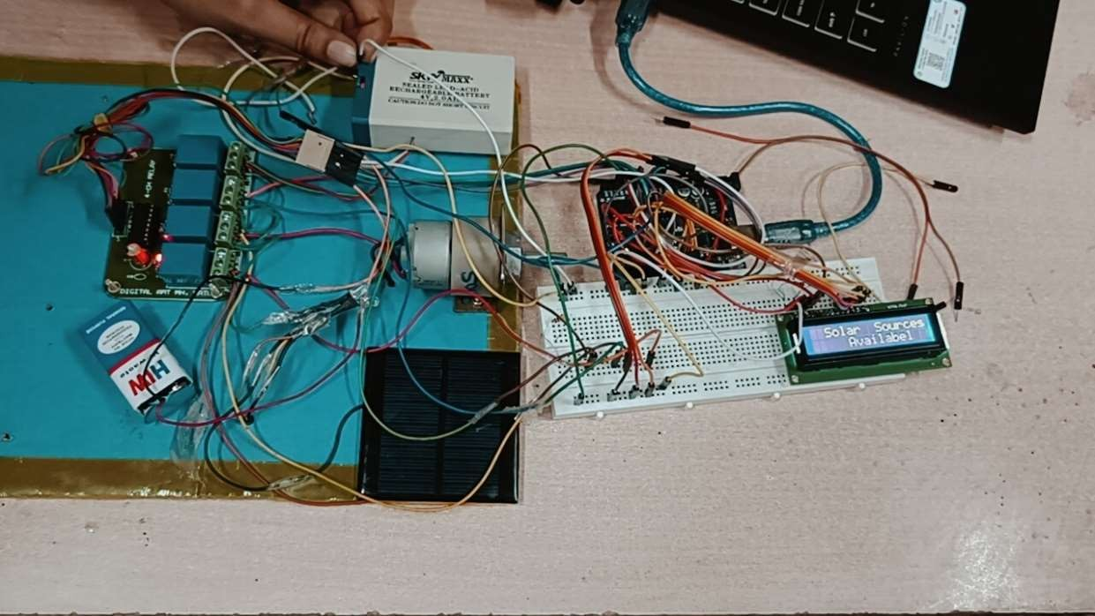

Figure 29: Hardware - Solar source is available

### Third, when generator supply is available

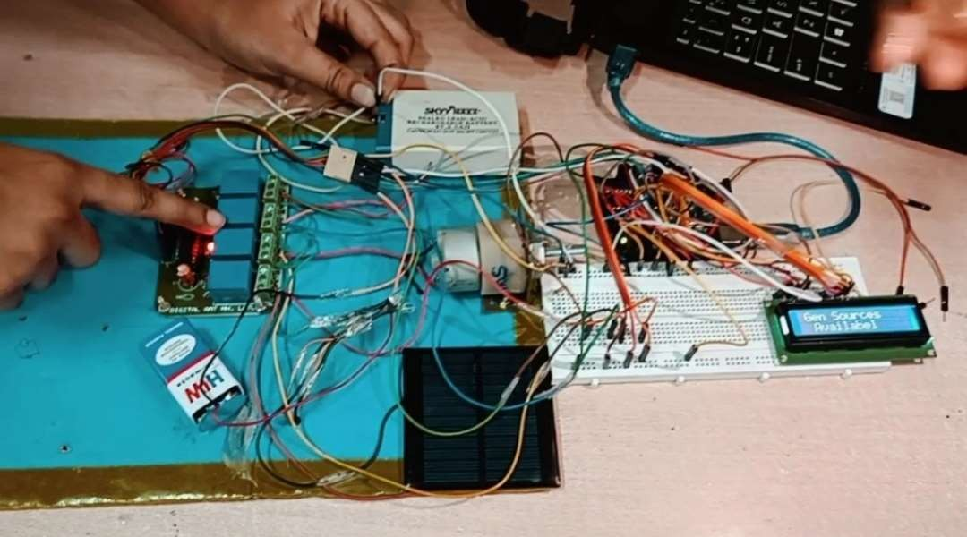

Figure 30: Hardware - Generator source is available

### Fourth, when Main source is available

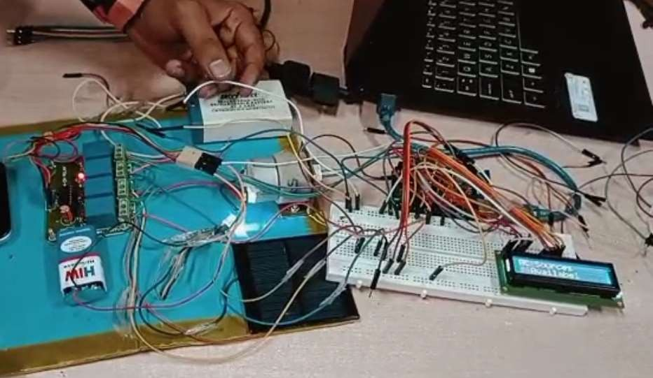

Figure 31: Hardware - AC source is available

### Fifth, when Battery source is available

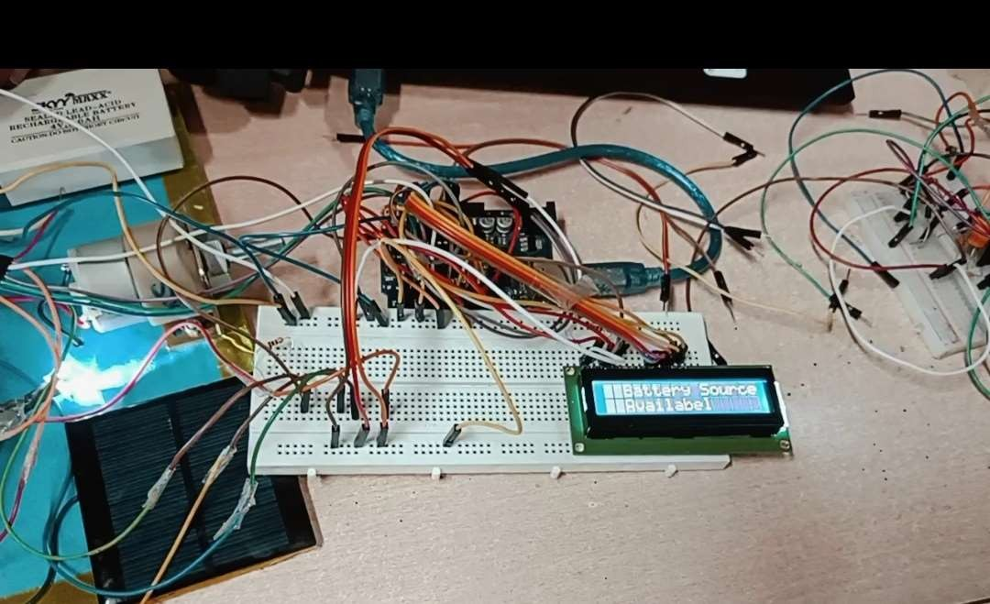

Figure 32: Hardware - Battery source is available

## Applications, Advantages and Disadvantages

### Applications

Main application of this project is to provide uninterrupted power supply to the load in various places -

Power supply can be control in:

* + - Industries
    - Hospitals
    - Banks
    - Schools, colleges, etc.

### Advantages

* + - Power supply can be controlled from four different sources.
    - if any problem occurred in one source, then other sources can be used

### Disadvantages

* + - Cost of the circuit is very high.
    - It’s very difficult to install and maintain the kit.

## Conclusion

This project intended to design an auto power control of four different sources circuit, the main scope of this project is to provide a continuous power supply to the load through any of the sources in the absence of any source. Taking in consideration the use of the source whose cost is the lowest then, the higher and so on.

## Future Scope of Development

Although this project describes uninterruptable power supply automatically, but there are some important elements which are needed to be added.

The circuit can be further enhanced by adding battery tracker so as to show the power level in the battery in order to help in the control arrangements.

In addition to this GSM which can be used as a remote control as well as to know the power status from outside the home or company.

## Reference

* https://microcontrollerslab.com/auto-power-supply-control-system/
* https://[www.researchgate.net/publication/322917231_Design_and_Implementation_of](http://www.researchgate.net/publication/322917231_Design_and_Implementation_of)

_an_Automatic_Power_Supply_from_Four_Different_Source_Using_Microcontroller

* https://youtube.com/playlist?list=PLKbSRxrdxkT3sRzWE465KoxOH00BFbRs6